# ***GRID GENERATION FROM POINTS***

1. **Load all the points and ploys in SMS. This can be done using option A or B**
2. **Convert point/poly shapefiles into feature objects (default coverage) (SMS)**
3. In SMS/GIS Module: Menu/Data/Add Shapefile Data (here add the points from marshes + boundary poly, + poly of the creek
4. FOR THE POINTS: Select (check) one of the GIS layer (e.g. points) – Then, with the black arrow icon in the vertical menu, select all the points. In SIM/GIS Module: Menu/Mapping/Shape🡪 Feature Objects.
5. Check “Create a new coverage” and Give it a name (bottom space). Select “Generic 2D Model”, then press “Next”
6. In the “Id” column, in the drop down menu choose “Create Mesh node at Point”. Then, Next and Finish
7. FOR THE POLYGONS: Select (check) one of the GIS layer (e.g. boundary poly) – Then, with the black arrow icon in the vertical menu, select the poly (or polys). In SIM/GIS Module: Menu/Mapping/Shape🡪 Feature Objects.
8. Check “Create a new coverage” and Give it a name (bottom space). Select “Generic 2D Model”, then press “Next”
9. In the “Id” column, in the drop down leave the only option that exits (because it is a poly). Then, Next and Finish
10. MERGING COVERAGES – Make sure that the following option is checked: Display\Display options\Inactive Coverages. Then click on top of all the layers that need to be merged, then, right click\Merge Coverages
11. Right click on the merged layer and select ***Type\Models\Generic 2D Mesh.*** This is very important!!!
12. **Create feature objects (points and polys) (default coverage) in SMS**
13. Load points
14. Put (load) an outer boundary
15. Select points (from vertical menu) and convert them to nodes

(Feature Objects\Vertices < -- >Nodes

1. In the Map Module:
2. Right click on “default coverage” (layer)
3. ***TYPE/Models/Generic 2D Mesh*** (remain checked)
4. Select all the points
5. Feature Objects\Attributes (and leave the options as below):

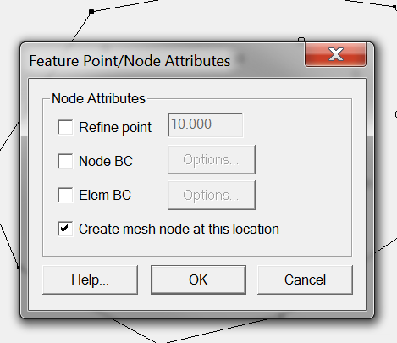

1. **In the Map Module: Feature Objects\Clean**

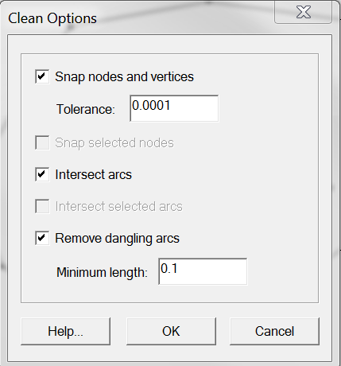

1. In the Map Module: Feature Object \Build polygons
2. In the Map Module: Feature Object \Map -> 2D Mesh\OK

